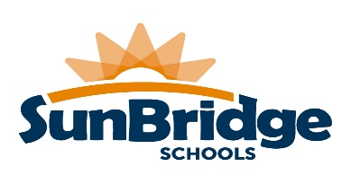

2729 124th Street
Toledo, OH 43611
419.725.5437
www.sunbridgeschools.org

July 21, 2023

As Ohio law states prior to November 1st of each year, students enrolled for the first time in either Kindergarten or 1st grade shall be screened for hearing, vision, speech/communications, health/medical problems and any developmental disorders. More information about these health screenings will be available as the year progresses. Vision and Hearing screenings will be administered during the months of September and October. Developmental screenings will take place throughout the year as needed.

Why is it important to have your child’s vision screened?
Young children with vision problems do not know the way that they see the world is not the way they should be seeing it! Without early detection and treatment, children’s vision problems can lead to permanent vision loss and learning difficulties.

Vision screening will consist of one or more of the following:
1. Distance visual acuity - ability to see objects far away
2. Binocular vision - how well your child’s eyes work together
3. Color vision - ability to see colors
4. Near visual acuity - ability to see objects up close

Why is it important to have your child’s hearing screened?
• Hearing is important for speech, language development, reading and learning.
• A hearing screening can detect if your child needs further hearing testing.
• Even if your child has passed a hearing screening previously, their hearing can change.
• Hearing problems can be related to medical problems.
• Hearing loss is invisible and child may appear to be not paying attention.

Hearing screening will consist of one or more of the following tests:
• Tympanometry - Screening of middle ear function to determine presence/absence of middle ear fluid and/or wax
which could interfere with normal hearing.
• Audiometry - Screening of hearing acuity.
• Otoacoustic Emissions (OAE) - An objective test that screens for an estimate of hearing sensitivity.

A hearing screening only provides a snapshot of how your child performs on the day the test was administered and is not a substitute for a complete hearing evaluation by an audiologist.

How will the results of the vision and hearing screenings be shared?
If your child passes the vision or hearing screening, you may receive a letter from your school with the results.
If your child does not pass the vision screening, the school will send a letter to share the results and may make a recommendation for further evaluation by an eye care specialist. If your child fails either part of the hearing screening, a rescreen and/or referral will be made.

If you have any questions about the school health screening program, please call the Nurse at 419.725.5437.

Thank you,
Nurse Kara, RN

